MORTSCAPE
Domain Competency Training
L1.1: Mortgage Banking Basics
Version No. 1.1



 | Prepared By | Reviewed by | Approved By
Name
Role
Signature
Date | 6th October 2005 | 10th October 2005

Project ID: 04763 KT document / Ver: 1.1

Release ID: QTTS-TSTKT.doc / 8.01 / 05.03.2004 C3: Protected
Table of Contents
1.0 Table of ContentsIntroduction 2
1.0 Introduction 4
1.1 Mortgages 4
1.2 Mortgage Banking 5
1.3 Risks 5
1.3.1 Credit Risk 5
1.3.2 Interest rate risk 5
1.3.3 Price Risk 6
1.3.4 Transaction Risk 6
1.3.5 Liquidity Risk 6
1.3.6 Compliance Risk 6
1.3.7 Strategic Risk 6
1.3.8 Reputation Risk 6
2.0 Types of Mortgages 7
2.1. Based on Guarantee 7
2.1.1. Government Loans 7
2.1.2. Conforming loans 7
2.1.3. Non-conforming loans 8
2.1.3.1. Alt-A 8
2.1.3.2. Subprime 9
2.1.3.3. Jumbo loans 9
2.2. Based on Interest Rates 10
2.3. Special Types 11
2.3.1. Bridge Loans 11
2.3.2. 80-10-10 (Piggyback Loan) Financing 11
2.3.3. Reverse Mortgages 12
3.0 Mortgage Market and Entities 13
4.0 Mortgage Banking Value Chain 17
4.1. Loan Production 18
4.1.1. Loan Origination 18
4.1.2. Loan Processing 18
4.1.3. Loan Underwriting 19
4.1.4. Loan Closing 19
4.2. Loan Servicing 19
4.2.1. Cash Management 20
4.2.2. Investor Accounting and Reporting 20
4.2.3. Document Custodianship 20
4.2.4. Escrow Account Administration 20
4.2.5. Delinquency Management 20
4.2.6. Customer Service 20
4.3. Secondary Marketing 21
5.0 Key Terms & Concepts 22
6.0 Mortgage Related Laws 25
6.1. Title Theory 25
6.2. Lien Theory 26
6.3. Fair Lending - Regulations related to prohibited discriminatory lending practices. 26
6.4. Consumer Affairs Laws and Regulations 27

Introduction

Mortgages
Mortgages are loans given to consumers for the purpose of purchase, construction or repair of real estate. Mortgages were started in the 1930s by insurance companies in the US, primarily with the hope of gaining ownership of properties if the borrower failed to make the payments on it. It wasn't until 1934 that mortgages, in their current form, came into being. The Federal Housing Administration (FHA) played a critical role in this process.
Mortgages can broadly be classified into four categories – Home, Multi-family, Commercial, and Farm mortgages.
- Home mortgage-Also known as 1-4 or single-family mortgages, these are the mortgages provided for purchase or construction of a home for occupancy of 1 to 4 families. These form the largest chunk of mortgages generated. Most of the subsequent discussion would be based on the single-family mortgages.
- Multi-family mortgage-Mortgages taken for apartment complexes, which house more than 4 families.
- Commercial mortgages-these are mortgages for development of commercial property including shopping complexes, hospitals, and office complexes.
- Farm mortgages-these are mortgages provided for purchase of farmlands.

Mortgage Banking
Mortgage banking generally involves loan originations, purchases, and sales through the secondary mortgage market. A mortgage bank can retain or sell loans it originates and retain or sell the servicing on those loans. Through mortgage banking, national banks can and do participate in any or a combination of these activities. Banks can also participate in mortgage banking activities by purchasing rather than originating loans. The mortgage banking industry is highly competitive and involves many firms and intense competition. Firms engaged in mortgage banking vary in size from very small, local firms to exceptionally large, nationwide operations. Commercial banks and their subsidiaries and affiliates make up a large and growing proportion of the mortgage banking industry.
When a bank originates a mortgage loan, it is creating two commodities, a loan and the right to service the loan. The secondary market values and trades each of these commodities daily. Mortgage bankers create economic value by producing these assets at a cost that is less than their market value. Given the cyclical nature of mortgage banking and the trend to greater industry consolidation, banks must maximize efficiencies and economies of scale to compete effectively. Mortgage banking operations can realize efficiencies by using systems and technology that enhance loan processing or servicing activities. The largest mortgage servicing operations invest heavily in technology to manage and process large volumes of individual mortgages with differing payments, taxes, insurance, disbursements, etc. They also operate complex telephone systems to handle customer service, collections, and foreclosures. This highly developed infrastructure enables mortgage banks to effectively handle large and rapidly growing portfolios. Mortgage banking operations also need effective information systems to identify the value created and cost incurred to produce different mortgage products. This is especially critical for banks that retain servicing rights. To optimize earnings on servicing assets, mortgage banks must have cost-efficient servicing operations and effective, integrated information systems.

Risks
The applicable risks associated with mortgage banking are: credit risk, interest rate risk, price risk, transaction risk, liquidity risk, compliance risk, strategic risk, and reputation risk.

Credit Risk
Credit risk is the risk to earnings or capital arising from a borrower’s failure to meet the terms of any contract with the bank or to otherwise fail to perform as agreed.

Interest rate risk
Interest rate risk is the risk to earnings or capital arising from movements in interest rates.

Price Risk
Price risk is the risk to earnings or capital arising from changes in the value of portfolios of financial instruments. This risk arises from market-making, dealing, and position-taking activities in interest rate, foreign exchange, equity, and commodities markets.

Transaction Risk
Transaction risk is the risk to earnings or capital arising from problems with service or product delivery. This risk is a function of internal controls, information systems, employee integrity, and operating processes. Transaction risk exists in all products and services.

Liquidity Risk
Liquidity risk is the risk to earnings or capital arising from a bank’s inability to meet its obligations when they come due, without incurring unacceptable losses. Liquidity risk includes the inability to manage unplanned decreases or changes in funding sources. Liquidity risk also arises from the bank’s failure to recognize or address changes in market conditions that affect the ability to liquidate assets quickly and with minimal loss in value.

Compliance Risk
Compliance risk is the risk to earnings or capital arising from violations of, or non-conformance with, laws, rules, regulations, prescribed practices, or ethical standards. Compliance risk also arises in situations where the laws or rules governing certain bank products or activities of the bank’s clients may be ambiguous or untested.

Strategic Risk
Strategic risk is the risk to earnings or capital arising from adverse business decisions or improper implementation of those decisions. This risk is a function of the compatibility of an organization’s strategic goals, the business strategies developed to achieve those goals, the resources deployed against those goals, and the quality of implementation.

Reputation Risk
Reputation risk is the risk to earnings or capital arising from negative public opinion. This affects the institution’s ability to establish new relationships or services, or continue servicing existing relationships.

Types of Mortgages
There are many types of mortgages in the market. These are designed to suit various requirements of the borrowers including the length of mortgage, capability for initial payment, and the other financial obligations. The products can be broadly classified in the based on the features which are as follows:

Based on Guarantee

Government Loans
These are loans either guaranteed/insured by The Federal Housing Administration (FHA), which is part of the U.S. Department of Housing and Urban Development, the Veterans Administration (VA), and the Rural Housing Service (RHS), which is a branch of the U.S. Department of Agriculture. These agencies do not typically originate loans (except for low income and other specific borrowers) directly but guarantee/insure loans originated by others provided they meet their underwriting norms.
- The financial requirements for FHA loans are relaxed compared to traditional commercial loans. So an individual with an adverse credit limit who is not eligible for a prime mortgage could be eligible for a FHA loan. Also, the interest rates charged on a FHA loan are lower than those for conventional loans.
- VA loans are designed for qualified veterans and offer more relaxed standards for qualification than either FHA loans or traditional loans. For example in 2002, loans can be for amounts up to $240,000 and require no down payment.
- RHS offers both guaranteed loans through approved lenders and direct loans that are government funded. These are offered to low-income families, living in rural areas or small towns for purchase, construction or repairing homes

Conforming loans
These loans with the loan size limitations, amortization periods, and underwriting guidelines set by Freddie Mac and Fannie Mae in secondary market. Conforming loans may be sold to the Freddie Mac or Fannie Mae (Government-sponsored enterprises or GSEs), which, in turn, securitize, package, and sell these loans to investors in the secondary market.

Non-conforming loans
These loans are not eligible for purchase by a GSE, but can be sold in the secondary market as whole loans, or can be pooled, securitized, and sold as private-label mortgage-backed securities. Non- conforming loans comprise Jumbo loans, Subprime loans and “Alt” A loans.

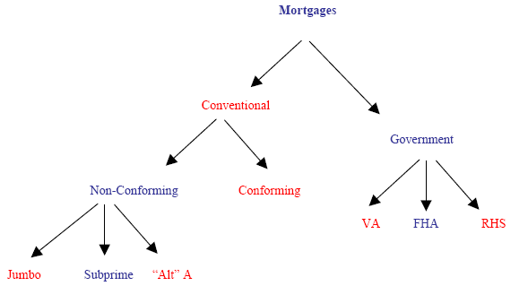

Alt-A
"Alt” A mortgage loan is provided to borrowers who have good job stability, good income, but their credit scores don't fit the "A Credit" guidelines. This could either be due to a short credit history or due to a slight derogatory hit on the credit scores such as a 30-day late payment.
Target market:
- Strong credit quality with non-standard needs, ex: limited documentation, stretch ratios
- Self-employed
- Need for process efficiency

Typical Guidelines:
- 680+ FICO (higher FICO required for increased LTV levels)
- Max LTV 75% - 90% range (over 80% requires primary MI)
- Credit history: no mortgage lates, no bk/ nod/ fcl in past 36+ mos, overall excellent credit
- Max Debt Ratio: (where calculated) 38% - 45% range
- Documentation: Stated Income, No Ratio
- Strong compensating factors for non-standard features

Sample Pool Profile:
- WA FICO = 730
- WA LTV = 70%
- Doc Types:
- Stated Income = 70%
- No ratio = 15%
- NINA = 10%
- Full Doc = 5%
- Owner Occupied = 90%
- Purchase / Rate Term Refi = 75%

Subprime
Subprime loans are loans given to borrowers with poor credit history whose credit characteristics do not meet the requirements of Fannie Mae & Freddie Mac. These loans typically have higher down payment and higher interest rates.

Target Market:
- Borrowers with blemished credit history

Typical Guidelines:
- Credit quality ranges from “B” to “D” as defined by lender
- FICO down to 500 or below; FICO drives credit grade
- Credit history allows for major derogatory credit
- Numerous mortgage and/or major credit lates
- Some credit grades may allow recent bk, nod, fcl
- Max Debt Ratios: 50% - 55%
- Max LTV: Tiered by credit grade
- Documentation: Full Doc

Sample Pool Profile:
- WA FICO = 600
- WA LTV = 80%
- Doc Types:
- Full/Alt Doc = 75%
- Stated Income = 25%
- Owner Occupied = 95%
- Loan Purpose:
- Cashout Refinance / Debt consolidation with cash out = 55%
- Purchase = 35%

Jumbo loans
Jumbo loans are the loans in which the loan amount is above the limit set by Freddie Mac & Fannie Mae. This limit changes annually based on the single- family home price survey done by the Federal Housing Finance Board. For example in 2002, a conforming loan limit was $300,700. Loans that are above that limit are called Jumbo loans. Jumbo loans have interest rates higher by about 0.25 percent to 0.50 percent than the conventional loans.

Based on Interest Rates
    - Fixed-Rate Mortgage (FRM)
This mortgage comes with an interest rate that will never change over the entire life of the loan irrespective of changes in the market rates and economic trends. However, there could be a change in the property tax and any insurance payments included in the monthly payment. The term of the fixed rate mortgage is usually 15, 20 or 30 years.

Product | Description
Fixed 40 Due in 30 | Fixed rate product

    - Adjustable-Rate Mortgage (ARM)
An adjustable-rate mortgage has an interest rate that changes based on changing market rates and economic trends. ARMs usually have an initial period of time during which the rate won't change. For example,. The interest rates for ARMs can be tied to one-year U.S. Treasury bills, rates on certificates of deposit (CDs), the London Inter-Bank Offer Rate (LIBOR), COFI or other indexes.
Eg 6 MO LIBOR
    - Hybrid Loans
Hybrid loans combine features of a fixed rate mortgage (FRM) and an adjustable rate mortgage (ARM). The hybrid loan’s interest rate and monthly payments are fixed over a specified period of time beyond which the loan will convert into and stay as an ARM for the remainder of the loan term. The initial rate may be fixed for 3, 5 7 or even 10 years beyond which the ARM takes over. The ARM adjusts every 6 to 12 months. The longer the initial rate stays fixed, the higher will be the rate but the initial rate of a Hybrid loan is usually lower than that of a 30 year FRM. The initial interest rate will be higher than an ARM since the rate remains fixed for much longer than that of a normal ARM. A normal ARM would offer a fixed rate for say 6 to 12 months.
Product | Description
IO 2/6 LIBOR (10yrs IO Period) | Hybrid with 2 (or 3 or 5) years fixed rate period, based on 6 month LIBOR with IO period of 10 years. Earlier these products had IO periods equal to the respective fixed rate periods.
IO 3/6 LIBOR (10yrs IO Period)
IO 5/6 LIBOR (10yrs IO Period)

    - Balloon Mortgage
A balloon mortgage offers an initial fixed interest rate for five to seven years and then requires a "balloon" payment. The balloon payment is the final payment of the loan and pays off the entire balance.
    - Graduated Payment Mortgages (GPMs)
A GPM would have a fixed interest rate with monthly payments that gradually increase by predetermined amounts during the early years of the loan and then level off, say after 5 years. A GPM would be useful for borrowers who expect their incomes to increase significantly over a period of time. However, GPMs carry the risk of having the loan principal to actually increase during the early years when payments are low and inadequate to meet the entire interest payment.

Special Types

Bridge Loans
Borrowers who plan to take a new home before selling their current one can go in for a bridge loan to span the gap between the two transactions. Bridge loans can either be structured to completely pay off the old home's mortgage or to add the financial obligation of the new home to the existing mortgage. Typically, the loan is structured with a short term (often one year) and hefty prepaid interest (perhaps six month's worth). Most often, a bridge loan is used to pay off the existing mortgage, with the remainder (minus closing costs and prepaid interest) going toward the down payment on the new home. If after six months the old home has not sold, the borrower begins making interest- only payments on the loan. When the home sells, the bridge loan is paid off. If it sells within the first six months, any unearned interest payments will be credited to borrower.

80-10-10 (Piggyback Loan) Financing
When the mortgage amount is more than 80 percent of the purchase price of the home, lenders require the borrowers to take insurance on the extra amount. It is called PMI (Private Mortgage Insurance) and the borrower pays for the premium. The cost varies but it can be equivalent of an additional 1/2 to 1 percent of the loan amount per year. Furthermore, this cost is not tax-deductible. With 80-10-10 financing, the borrowers make cash down payment of 10 percent of the purchase price. They take out two mortgages: a new first mortgage for 80 percent of the price and 10 percent second mortgage. Often the first and second mortgages are from the same lender.
The interest rate on the second mortgage will be about 2 percent higher than the going rate on first mortgages. This allows the borrowers to save money spent on the PMI.

Reverse Mortgages
Reverse Mortgages - Reverse mortgages pay money to the borrower as long as the borrower lives in his/her home. These loans are designed for people aged 62 and above who own their homes and need an inflow of cash. The loan is against the equity of home and isn't paid off until the borrower sells or moves out of the home. The payment can be a single lump sum, regular monthly payments, or a as a "creditline" account that lets the borrower decide when and how much of the available cash is paid. Against this, the lender gets an equivalent amount of ‘equity’ in the home, which they can claim once the home is liquidated after the borrower does or moves away. All types of Conventional and Government loans (except VA loans) are available with ARM options.

Mortgage Market and Entities
There are various players who participate in the functioning of the mortgage banking. The two obvious players are the borrower and lender. Traditionally lenders have managed all the required functions of prospecting a customer, providing the loan, servicing the loan, and managing the risk by themselves. However, as the market matured, the functions of origination, servicing, risk management and funding are unbundled and managed by different specialized entities.
The mortgage market can be presented as below:

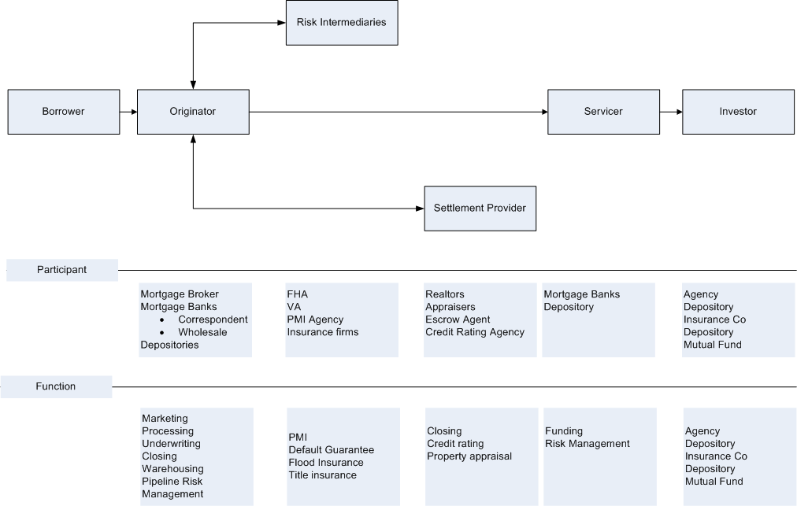

Originators perform the role of accessing the prospect’s credit worthiness and deciding on the best product to suit their needs and ability to pay. These are the entities that actually provide the mortgage loans. The borrower can directly contact an originator or go through an intermediary like a broker or a correspondent lender.
  - Mortgage bankers sell all the loans they create in the secondary market because they do not have the long-term funding sources necessary to hold mortgages permanently.
  - A Correspondent could be defined as entity that typically sells the Mortgages it originates to other lenders. The Correspondent performs some or all the loan processing functions such as taking the loan application; ordering credit reports, appraisals, and title reports; and verifying the borrower's income and employment.
  - A Mortgage Broker could be defined as a person or entity that specializes in loan originations, receiving a commission to match borrowers and lenders.
  - Portfolio lenders include commercial banks, savings banks, savings and loan (S&L) associations, and credit unions. They are called "portfolio" lenders because they tend to originate loans for their own portfolio (usually adjustable rate loans), not for resale in the secondary market.
Risk intermediaries provide insurance to make the loan process more viable. There are private insurance entities that provide Private Mortgage Insurance (PMI), Flood Insurance, Title Insurance, Hazard Insurance, etc. Some example include,
- Private Mortgage Insurance (PMI) is provided in cases where the borrower makes a low down payment. In this case, the norm of 80% for the Loan to Value (LTV) ratio is exceeded. The insurance is provided for the amount over and above the value that meets the LTV ratio of 80%.
- Flood Insurance is provided to protect against losses due to floods.
- FHA, VA, and RHS are the government-backed agencies that provide insurance in mortgages.
Settlement Services Providers provide various services required for underwriting and closing a loan. These services include Credit Reporting3, Property Appraisal, and Loan Closing.
- Credit Reporting Agencies: These agencies undertake the credit check on the borrower spending and credit history. There are three big agencies: Experian, Equifax, and Trans Union, all with national databases. Each credit reporting agency collects information from banks, finance companies, department stores, taxing authorities, landlords, and other "credit grantors" and keeps the information in the borrowers’ file.
- Property Appraisal Agency: An appraisal of real estate is the valuation of the rights of ownership. The appraiser does not create value; the appraiser interprets the market to arrive at a value estimate. As the appraiser compiles data pertinent to a report, consideration must be given to the site and amenities as well as the physical condition of the property.
- Loan Closing Agencies: These agencies are the party designated to conduct the loan closing, and to ensure the mortgage or deed is recorded and the funds disbursed on time. The closing agent can be an escrow company, an attorney or title company agent depending on the region.

Loan Servicing firms provide the servicing of a loan – collecting the monthly payments, reporting to the investors, and handling the cases of delinquency. Some of the mortgage origination firms outsource the servicing function to focus on origination. Also, some firms purchase pools of loan after origination and manage the servicing function.
- Primary servicer ensures that cash flows reach their appropriate destination in a timely manner. The primary servicer is also responsible for escrow administration, and for investor reporting. The servicers can be of different types based on their roles & responsibilities. Sometimes these functions are referred to a special servicer who excels at dealing with problem loans.
- Master servicer is responsible for protecting the interests of investors by overseeing the actions of the primary servicers and any others involved in the issue and by ensuring timely remittance of funds.
- Special servicers are responsible for working the more difficult, often nonperforming loans, first-payment delinquencies, and/or handling the Real Estate Owned (REO) process.
- Subservicer: These participants perform much of the primary servicer’s role on a fee basis, but do not actually own the servicing rights.

The secondary market consists of GSEs, private investors, banks, financial institutions, insurance companies, pension funds and mortgages investment trusts that buy and sell mortgages as an income stream for their portfolio.
- Players in Securitization process
- Issuer - The entity that pools the loans in preparation for structuring their cash flows into securities to a special-purpose vehicle (SPV)
- SPV - Uses funds raised by issuing debt securities to fund the purchase. In order to avoid double taxation, the SPV is typically structured as a trust and in the case of residential mortgages takes the specific form of a Real Estate Mortgage Investment Conduit (REMIC).
- Investment banker - Once the pool is assembled and due diligence performed on the loans, preparations are made to transfer them to a SPV. This may be done by the issuer ‘in house’ or with the assistance of a separate investment banking organization that structures the cash flows into securities with characteristics designed to meet market demand. The investment banker or underwriter may also guarantee the sale of the securities.
- Credit rating agencies - The level of credit enhancement is determined by credit rating agencies (Fitch Ratings, Moody’s, and Standard & Poors) based on collateral quality, servicer rating, issuer reputation for due diligence, and other factors.
- Investor - There are a variety of investor types and there are likewise a variety of motivations for investing in MBS and ABS. Often investors such as pension funds and insurance companies are seeking to generate cash inflows to match their own prospective cash outflows. Others use mortgage securities to hedge other positions, especially around interest-rate risk. Others, such as thrifts, may be looking for assets more liquid than their investment alternatives.
- Government Sponsored Enterprises (GSEs) The majority of mortgage securities is issued/ and or guaranteed by an agency of the US government: The Government National Mortgage Association (Ginnie Mae), or by Government Sponsored Entities (GSEs) such as Federal National Mortgage Association (Fannie Mae) and the Federal Home Loan Mortgage Corporation (Freddie Mac). These organizations are federally chartered agencies that support the secondary mortgage market through mortgage purchase and securitization programs. Fannie Mae and Freddie Mac are privately owned, government sponsored agencies that act as conduits-purchasing mortgages and selling securities backed by mortgages. Ginnie Mae, in contrast, is a government owned, government-sponsored agency that guarantees MBSs backed by mortgages insured or guaranteed by FmHA, HUD/FHA and VA.
- Private Conduits Some private institutions also package loans and issue securities. Private conduits buy nonconforming mortgages from multiple lenders and package them into salable securities. Private conduits are highly capitalized, and willing and able to take risk. The existence of conduits allows small lenders to participate in the secondary mortgage market that might not be able to otherwise. Some of the popular private conduits are Sears, RAC, GMAC and MGIC.

Mortgage Banking Value Chain
Mortgage banking involves three major areas of activities: loan production, secondary marketing, and servicing. Each of these activities is normally performed in a separate unit or department of the bank or mortgage banking company.
- The loan production unit originates processes, underwrites, and closes mortgage loans.
- The secondary marketing unit develops, prices, and sells loan products and delivers loans to permanent investors also it is responsible for the pipeline and warehouse management which involves managing price risk from loan commitments and loans held-for-sale.
- The servicing unit (sometimes referred to as loan administration) collects monthly payments from borrowers; remits payments to the permanent investor or security holder; handles contacts with borrowers about delinquencies, assumptions, and escrow accounts; and pays real estate tax and insurance premiums as they become due.
Each of the segments has been broken down further per the functionality:
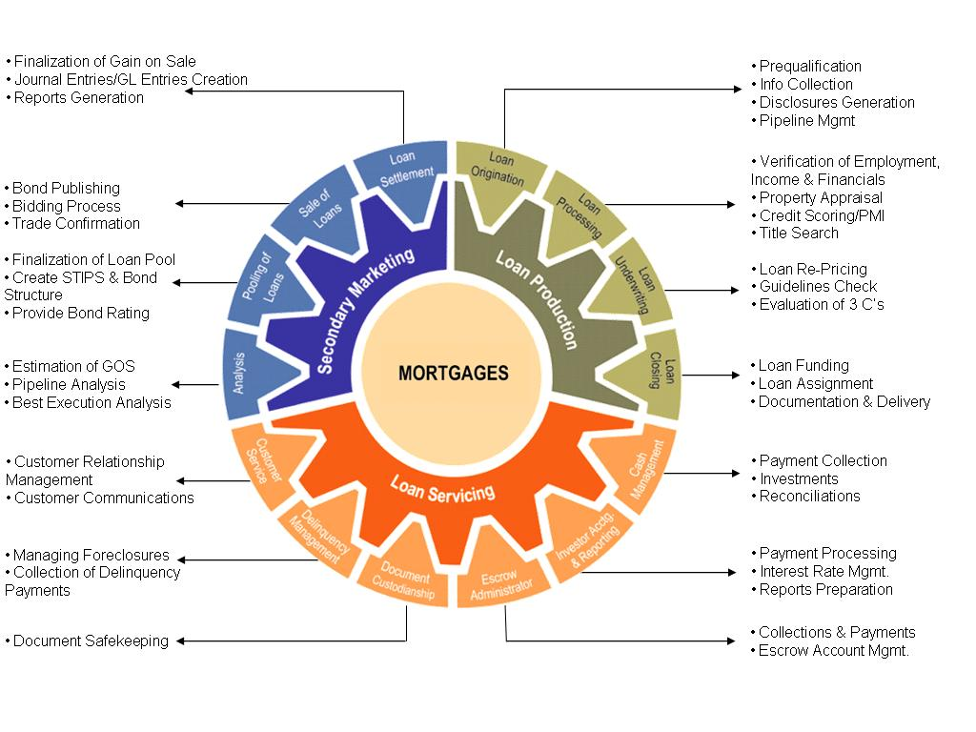

The Mortgage process as in the value chain has been discussed briefly below:
- Loan Production,
- Loan servicing and
- Secondary Marketing

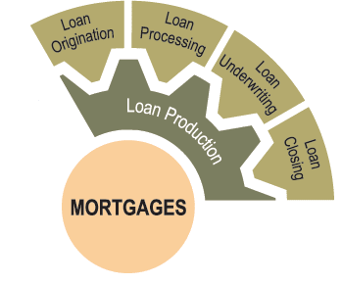
Loan Production
(Details in L1.2: Loan Servicing Material)
Loan Production involves Loan Origination, Loan Processing, Loan Underwriting and Loan Closing. (Details in L1.2: Mortgage Production Material)

Loan Origination
This stage broadly consists of two set of activities:
- Pre-qualification: Pre-qualification process is based on estimating the affordability of the borrower for mortgage payments.
- Disclosures generation: According to the federal government guidelines, a set of disclosure documents need to be generated and sent to the borrower, once the borrower agrees to apply for the loan from the lender. These documents are GFE doc, TIL doc & servicing disclosure statement.

Loan Processing
This stage broadly consists of four major activities:
- Verification of Income, Employment & Financials: Earning statements, profit and loss statements and tax returns for current year and previous two years, docs for social security, overtime bonus, commission, interest income, veteran's benefits etc is verified.
- Property Appraisal: An appraisal is an estimate of the value of a property, made by a qualified professional, called an appraiser
- Credit Scoring: Ordering of the Credit reports for the borrower from the credit reporting agencies.
- Title Search: A title search is a detailed examination of the historical records concerning a property.

Loan Underwriting
This stage broadly consists of three major activities:
- Evaluation of 3Cs: Evaluation of Credit, Collateral & Capacity
- Total Credit Liability
- Total Asset
- Total Monthly Income
- Validation and Review of Borrower Information details: The loan underwriter does a second level review and validation of all the documents to verify information supplied by a mortgage applicant, such as income, employment, and down payment sources.
- Loan Re-pricing: The loan parameters will be checked against the guidelines provided by the private investors or the GSE (Government s to arrive at various loan pricing scenarios.

Loan Closing
This stage broadly consists of three set of activities:
- Loan Funding: The closing agent will make sure that all necessary papers are signed and recorded and that funds are properly disbursed and accounted for when the closing is completed.
- Loan Documentation & Delivery: Loan closings may be performed by an internal loan-closing unit or by title companies or attorneys acting as agents for the bank.
- Post Funding Quality Control: HUD, Freddie Mac, Fannie Mae, Ginnie Mae, and most private investors require the lender to have a quality control unit that independently assesses the quality of loans originated or purchased.

Loan Servicing
(Details in L1.3: Loan Servicing Material)
Loan servicing refers to that part of the value chain starting from the closure of the loan, till it is fully repaid and settled. It includes activities such as periodic payments management, accounting, investor reporting, customer servicing, records management etc.
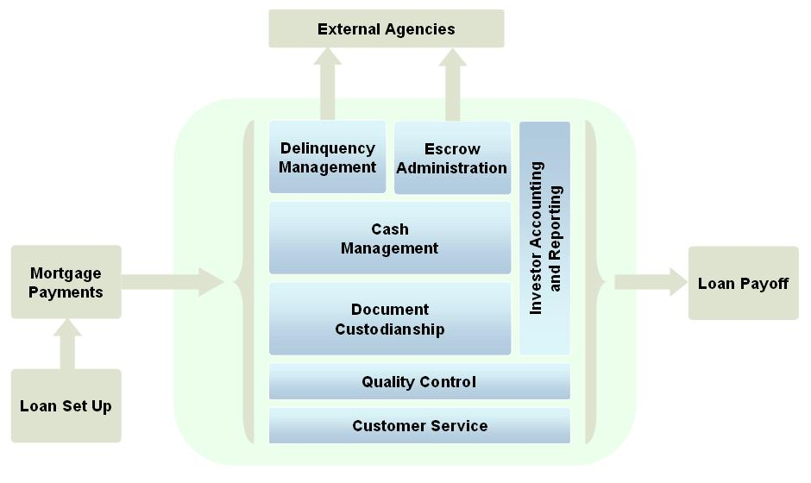
Loan servicing consists of the following major activities namely:
- Cash management
- Investor accounting and reporting
- Document custodianship
- Escrow account administration
- Delinquency Management
- Customer service

Cash Management
Cash management consists of collecting borrowers’ mortgage payments and depositing those funds into custodial accounts. The mortgage payment consists of Principal, Interest, Taxes and Insurance (PITI). The principal and interest portion of each payment is separated from the portion set aside for escrow items (insurance & taxes). These custodial accounts require daily balancing and monthly reconciliation, control over disbursements, and the deposit of funds into appropriate financial institutions.

Investor Accounting and Reporting
Investor accounting and reporting consists of performing various recordkeeping functions on behalf of investors.

Document Custodianship
In this function, the servicer is responsible for ensuring collateral documents are obtained and released for loan servicer portfolio. A servicer may himself be involved in document custodianship or may outsource it to a third party agency.

Escrow Account Administration
During escrow analysis, the lender reviews escrow amount and determines if it is adequate to cover the fees for insurance, taxes and any other premiums paid through escrow. If the amount is found to be insufficient, the lender may ask to increase regular monthly payment. If it is new servicer's policy to review escrow accounts as soon as the servicing is transferred payment may change immediately, the borrower should receive an explanation regarding any changes.

Delinquency Management
Delinquency Management basically refers to default Management, which includes tracking and reporting the status of loans that are in various stages of default.

Customer Service
The loan servicer is required to provide information to borrowers on their mortgage loans. Generally, the loan servicer has a toll free number that borrowers may call for information on such items as loan balances, interest paid, amortization schedules, escrow balances, etc.

Secondary Marketing
(Details in L1.4: Secondary Marketing Material)
Banks raise deposits and use the money to provide loans & mortgages. So the ability of a bank to provide loans is limited by the extent to which it can raise deposits. This, on an aggregate scale, also limits the total demand that the mortgage market can manage.
In order to increase this limit, the secondary market evolved. Unlike the primary market, which concerns all the processes required to bring a mortgage into existence, the Secondary Mortgage market is that portion of the mortgage market in which lenders, government-sponsored agencies, private conduits and investors buy, sell and trade existing mortgages. This market serves as an outlet to sell the originated loans to help generate funds for continued lending.
For the homebuyer, the secondary market makes funds and a wide array of financing alternatives available. For the lender, it can increase profits and help reduce the risks of mortgage lending by making available a liquid market for mortgages.
Secondary Marketing basically consists of the following processes -
- Loan Sales: Sell whole loans, participations and mortgage-backed securities. A bank’s secondary marketing department, working with production management, is responsible for developing, pricing, selling, documenting, and delivering mortgage products to investors. A bank must consistently demonstrate reliable performance in underwriting, documenting, packaging, and delivering quality mortgage products to remain in good standing with secondary market participants. Poor performance of loans sold could lead to unfavorable prices for future sales or terminated relationships
- Pricing: Price loans in correlation to ever-changing market forces so that the company produces value from the loans it produces.
- Pipeline Management: Keep track of the warehouse line limits and requirements. Using the pipeline reports, estimate how many loans will close, when they will close, and how the company will fund those closings
- Risk Management: Monitor and manage risks in the mortgage market such as interest rate fluctuation
- Shipping & Delivery: Preparing and delivering documents to investors as quickly as possible to avoid interest rate risk, to meet commitments, and to release the warehouse line for new lending

Key Terms & Concepts
(Details in Mortgage Glossary)

Amortization | The process of reduction in the principal balance outstanding is known as amortization.
Cash-Out Refinance | A refinancing arrangement in which the amount of money received from the new loan exceeds the total of the money needed to repay the old debt, closing costs, and property improvements.
Closing Costs | Money paid by the buyers and sellers to affect the closing of a mortgage. Closing costs normally include an origination fee, discount points, title insurance, survey, attorney’s fee, and such prepaid items as taxes and insurance escrow payments.
Collateral | Legal documents specifying ownership of homes (e.g. mortgage deed of trust, lien, etc.).
Delinquency | Loans in which the borrower has not made scheduled payments for one or more cycles. Loans that are more than a certain number of days delinquent (depends on the state) can be foreclosed upon. Delinquencies must be accounted for because they affect scheduled principal and interest payments. More general, any financial obligation on which the payment is overdue.
Escrow Account | A trust account into which a borrower’s funds are deposited monthly to pay taxes and insurance premiums. This account is also know as an escrow/impound account.
First Mortgage | A mortgage which is the primary lien against a property.
Foreclosure | A legal procedure in which a mortgaged property is sold in a legal process to pay the outstanding debt in case of default.
Homeowner’s Insurance | Insurance carried by the homeowner to protect the dwelling against fire and other hazards.
Home Mortgage Disclosure Act (HMDA) | Federal regulation requiring the collection of certain information from an applicant. The purpose of the act was to ensure banks are meeting the credit needs of the communities that it serves and are extending credit fairly to all borrowers.
HUD | The U.S. Department of Housing and Urban Development; responsible for the implementation and administration of government housing and urban development programs.
Index | A published interest rate, such as the prime rate, LIBOR, T-Bill rate, or the 11th District COFI. Lenders use indexes to establish interest rates charged on mortgages or to compare investment returns. On ARM (Adjustable Rate Mortgages), a predetermined margin is added to the index to compute the interest rate adjustment.
Investors | Investors are Financial Institutions who provide capital (funds) to the lenders. Investors provide capital by purchasing whole loans or securities backed by loans in the secondary market.
Liquidation | The application of a payment to a mortgage loan which reduces the outstanding principal balance to zero. Also, the sale or disposition of an asset.
Combine Loan-To-Value (CLTV) | The CLTV is obtained by dividing the sum of the amount of the first mortgage Loan and the second mortgage Loan amount (or credit line amount, if a HELOC) and any other subordinate financing, by the value of the subject property.
Loan-To-Value (LTV) | The ratio of the outstanding principal balance of the mortgage to the lower of the appraised value or purchase price of the mortgaged property expressed as a percentage.
Mortgage | A formal document, including the security instrument, note, title evidence and all other necessary documents and papers, which are executed by the borrower when pledging the property as security for the payment of a debt.
Mortgage Backed Securities (MBS) | An investment instrument backed by mortgage loans as security. Ownership is evidenced by an undivided interest in a pool of mortgages or trust deeds. Income from the underlying mortgages is used to pay interest and principal on the securities.
Mortgage Insurance Provider | A company providing mortgage insurance protecting lenders from financial loss in the event of borrower default.
Mortgage Servicing Rights | The contractual obligations undertaken by one party to provide servicing for mortgage loans owned by another party, typically for a fee.
Paid Outside Of Closing ("POC") | Some fees may be listed on the HUD-1 to the left of the borrower’s column and marked "P.O.C." Fees such as those for credit reports and appraisals are usually paid by the borrower before closing/settlement. They are additional costs to the borrower. Other fees such as those paid by the lender to a mortgage broker or other settlement service providers may be paid after closing/settlement. These fees are usually included in the interest rate or other settlement charge. They are not an additional cost to borrower. These types of fees will not be added into the total on Line 1400.
Partner | A party involved in the Master Servicing process including Trustees, Custodians, Sellers, and Servicers.
DTI (Debt to Income Ratio) | The underwriter begins the process of calculating the debt-to-income ratio by identifying two main factors that influence the repayment of a mortgage loan:  - Debt  - Income  Debt and income are identified, and the relationship between the two is evaluated to make certain the ratios meet program specific guidelines.
PITI | Principal, interest, taxes and insurance, which comprise the borrower’s housing expense.
Prepayments | The payment of all or part of a mortgage debt before it is due. Equivalent to payoffs if paid in full.
Principal | The remaining balance owed on a loan by a borrower or on a security by its issuer, exclusive of any accrued interest.
Refinancing | Repayment of a debt with the proceeds of a new loan using the same property as collateral.
Second Mortgage | A mortgage that has a lien position subordinate to the first mortgage.
Trustee | A third party that acts as an advocate on behalf of security holders. The trustee is often also the Custodian and Paying Agent.
Underwriter | Analyst who assesses the risk involved in making a mortgage loan to determine if it meets the lender’s criteria.
Wire | A payment system operated by the Federal Reserve for the transfer of Federal Funds balances between financial institutions maintaining accounts at U.S. Federal Reserve Banks.
Foreclosure | Foreclosure is the process by which the lender takes possession of the borrower’s home and sells it in order to get its money back in case of payment defaults.

Mortgage Related Laws
Whenever a mortgage loan is originated or in other words financing is involved in a real estate purchase, it is subjected to the title or lien theory of mortgages. The way in which a state will interpret how mortgage law is followed will be determined by which type of theory is practiced in that state. Each theory has special considerations on who will hold the title and how foreclosure proceedings would take place if they became necessary.

Title Theory
- The borrower does not actually keep title to the property during the loan term.
- The seller gives the buyer/borrower a deed to the property.
- When the borrower signs the mortgage for the loan the borrower gives the title back to the mortgage holder.
- The lender then holds title to the property, as security only, until all loan payments have been made
- Borrower has the right to possession of the property
- Lender delivers the deed back to the borrower only after the loan obligation has been satisfied.

Lien Theory
- Buyer holds the deed to the property during the mortgage term
- Buyer promises to make all payments to the lender
- The mortgage becomes a lien on the property but title remains with the buyer
- The lender's lien is removed once the payment of all loan payments have been completed

There are many regulations governing the way banks providing mortgage products need to conduct their business. Most of them have been put in place to ensure that the borrower has sufficient transparency on the charges for the mortgage. Couples of key regulations are:

Fair Lending - Regulations related to prohibited discriminatory lending practices.
These regulations prohibit discrimination in lending and other services on basis of age/ location/ color/ religion etc and provide for
- Nondiscriminatory Appraisal and Underwriting
- Nondiscrimination in Application Processing
- Nondiscriminatory Advertising
- Availability of Equal Housing Lender Poster in all offices
- Mandatory to maintain loan registers and file them with the compliance organizations.
The key laws that form a part of the Fair Lending Regulations are:
Fair Housing Act: This Act makes it unlawful for any lender to discriminate in its “residential real estate-related” activities against any person because of race, color, religion, sex, handicap, familial status, or national origin.
Home Mortgage Disclosure Act (HMDA): HMDA is a disclosure law to provide the public with information that will help show whether financial institutions are serving the housing credit needs of the neighborhoods and communities in which they are located. Mortgage firms need to collect and disclose data on applicant and borrower characteristics so that disparate lending patterns can be identified and reviewed for compliance with HMDA goals.

Consumer Affairs Laws and Regulations
These regulations ensure that customers taking loans for personal reasons are provided with sufficient safeguards against unfair practices.
The key regulations include:
Fair Credit Reporting Act (FCRA): FCRA indicates that consumer reporting agencies generating and transmitting customer data need to have permissible reasons for generating or using the data. Since Mortgage origination firms typically are users of this data and they need to follow guidelines on when they can ask for customer data. These organizations also need to maintain data justifying the use of customer data & also consent from the customer to obtain this data (credit reports etc.).
Truth In Lending Act (TILA): TILA ensures that credit terms are disclosed in a meaningful way so that consumers can compare credit terms more knowledgeably. This serves to protect consumers against inaccurate and unfair credit billing practices. TILA provides tolerance limit for errors in calculating annual percentage rates or charges as well as guidelines for making disclosures on various transactions (high value, low value, variable rate, fixed rate mortgages).
Restitution: Financial institutions that violate certain provisions of the TILA law might be required to reimburse borrowers for faulty disclosures. This could be for understatements of the annual percentage rate (APR) or finance charge disclosures resulting from a clear and consistent pattern or practice of disclosure errors, a gross negligence or a willful violation of the Act.
OTS Mortgage Regulations: These provide that sufficient disclosures regarding the interest rate and the adjustments (in case of ARMs) need to be provided before the processing fee is paid for a mortgage. The information to be disclosed includes the fact that the interest rate may change, the index or formula for these adjustments, and the breakup of interest rate & principal. This is applicable only to Thrifts8.
Real Estate Settlement Procedures Act (RESPA): RESPA requires lenders, mortgage brokers, or servicers of home loans to provide borrowers with pertinent and timely disclosures regarding the nature and costs of the real estate settlement process.
Consumer Leasing Act (CLA): CLA assures that meaningful and accurate disclosure of lease terms is provided to consumers before entering into a contract. This enables consumers to easily compare one lease with another, as well as compare the cost of leasing with the cost of buying on credit or the opportunity cost of paying cash.

